 **Appendix A**

|  |  |
| --- | --- |
| **Subject** | **Public Health Children's Update and Areas of Concern** |
| **To** | Education and Children's Services Scrutiny Committee |
| **From** | Dr Sakthi Karunanithi, Director of Public Health  Ruksana Sardar-Akram, Interim Consultant in Public Health |
| **Date** | 18 January 2022 |

1. **Purpose**

To provide the Education and Children's Services Scrutiny Committee with a Public Health update on children's health and wellbeing and to highlight inequalities and areas of concern.

1. **Background**

The pandemic has had a huge impact on the health and wellbeing of children and young people. The demand on Public Health to manage COVID-19 within education settings continues to be a challenge, which also impacts on the delivery and commissioning of services for children and young people. This will inevitably have some impact on the outcomes for children and young people and their families.

This report provides an overview in relation to COVID in children, as well as an update on child health outcomes based on national indicators and child health profiles. The true extent of inequality is not yet known and much of the data is annually if not longer, however, the following does provide an update in relation to the health of children in Lancashire.

1. **What is the data telling us?**
   1. **Coronavirus in Children and Young People is Still a Major Public Health Issue**

Coronavirus is still very much a key health protection priority for public health. As can be seen from the data, children have seen the impact in terms of disruption to education previously.

Although there has been a change in guidance recently, to avoid disruption to face-to-face education and allow children under-18 as close contacts into school, we are still seeing rising cases within education settings. Compared to December 2020, the rates of Coronavirus were particularly high in the elderly but this year we have seen a significant increase in the number of positive cases within educational settings and more recently in primary schools.

This has led to high numbers of children isolating as well as a lack of capacity to deliver face-to-face education within a small number of settings. This has been a particular area of concern amongst young children where vaccination has not yet been rolled out.

This has led to recruitment of additional staff in Public Health to manage outbreaks.

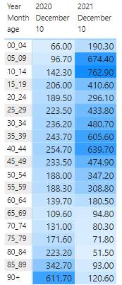

* 1. **What is the Data Telling Us About Children and Young People in Lancashire?**

This child health profile provides a snapshot of child health in Lancashire. It is designed to help us improve the health and wellbeing of children and tackle health inequalities. Overall, comparing local indicators with England averages, the health and wellbeing of children in Lancashire is worse. There are, however, local variations and inequalities within Lancashire where some districts and wards are even worse.

The charts below show how children's health and wellbeing compared with the rest of England.

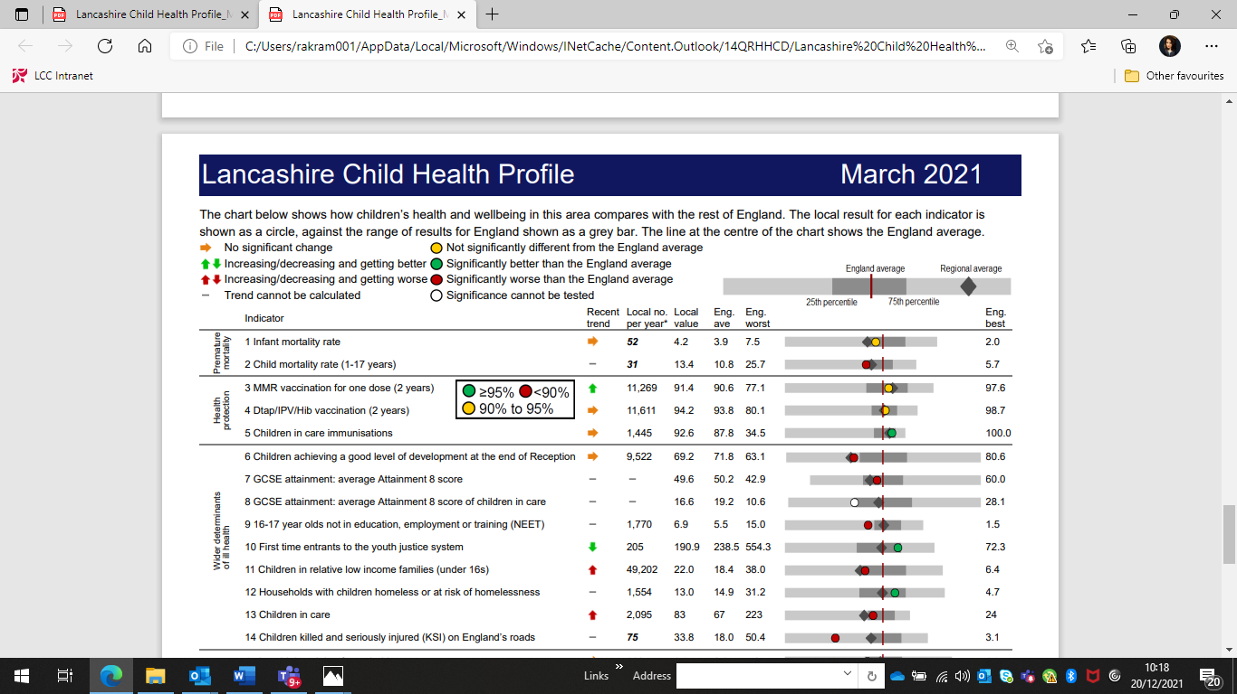

* + 1. **Mortality Data**

Infant mortality is not significantly different to England, although there are local variations with inequalities in some areas such as Burnley having higher rates of Infant Mortality. The Lancashire child mortality rate is 13.4 which is worse compared to 10.8 in England.

|  |  |  |  |  |  |  |
| --- | --- | --- | --- | --- | --- | --- |
| **Indicator** | **Recent trend** | **Local no. per year\*** | **Local value** | **Eng. average** | **Eng. worst** |  |
| Infant mortality rate |  | 52 | 4.2 | 3.9 | 7.5 |  |
| Child mortality rate  (1-17 years) | - | 31 | 13.4 | 10.8 | 25.7 |  |

* + 1. **Health Protection**

Health protection is a key public health domain. The take up of vaccination is similar to England with Measles, Mumps and Rubella (MMR) take up improving. Immunisations are better for children in care.

|  |  |  |  |  |  |  |
| --- | --- | --- | --- | --- | --- | --- |
| **Indicator** | **Recent trend** | **Local no. per year\*** | **Local value** | **Eng. average** | **Eng. worst** |  |
| MMR vaccination for one dose  (2 years) |  | 11,269 | 91.4 | 90.6 | 77.1 |  |
| Dtap/IPV/Hib vaccination  (2 years) |  | 11,611 | 94.2 | 93.8 | 80.1 |  |
| Children in care immunisations |  | 1,445 | 92.6 | 87.8 | 34.5 |  |

* + 1. **Wider Determinants of Health**

If we are going to improve health outcomes for children, young people, and their families, it is important we consider inequalities in the wider determinants that impact on health and wellbeing such as poverty, education, employment, and housing.

Many child outcomes in Lancashire are worse than the England average and getting worse for children under-16 in relative low-income families and children in care. Children achieving a good level of development at the end of reception is also worse than England, as is the number of children killed and seriously injured on our roads. The number of entrants into the youth justice system, however, is better than England and is improving.

|  |  |  |  |  |  |  |
| --- | --- | --- | --- | --- | --- | --- |
| **Indicator** | **Recent trend** | **Local no. per year\*** | **Local value** | **Eng. average** | **Eng. worst** |  |
| Children achieving a good level of development at the end of Reception |  | 9.522 | 69.2 | 71.8 | 63.1 |  |
| GCSE attainment: average Attainment 8 score | - | - | 49.6 | 50.2 | 42.9 |  |
| GCSE attainment: average Attainment 8 score of children in care | - | - | 16.6 | 19.2 | 10.6 |  |
| 16-17 year olds not in Education, Employment, or Training | - | 1,770 | 6.9 | 5.5 | 15.0 |  |
| First time entrants to the youth justice system |  | 205 | 190.9 | 238.5 | 554.3 |  |
| Children in relative low-income families (under 16s) |  | 49,202 | 22.0 | 18.4 | 38.0 |  |
| Households with children homeless or at risk of homelessness | - | 1,554 | 13.0 | 14.9 | 31.2 |  |
| Children in care |  | 2,095 | 83 | 67 | 223 |  |
| Children killed and seriously injured on England’s roads | - | 75 | 33.8 | 18.0 | 50.4 |  |

* + 1. **Health Improvement**

Improving health is a key public health domain and critical in preventing and reducing ill health and mortality. Almost all areas in Lancashire are worse than the England average and where they have been similar, such as obesity in children age 10-11, this is now getting worse. Factors such as low birth weight, under-18 conception, smoking, and substance use in pregnancy can also contribute to infant mortality. Hence focussing on best start and the 1001 critical days from conception, birth, and beyond are crucial. Local variations and inequalities exist across Lancashire and some areas are much worse than the others.

Clear links also exist between deprivation, child obesity, and oral health so in some areas place based interventions are required at local level to address these inequalities. Recent data on oral health suggest Lancashire has more five year olds with visually obvious dental decay, and one or more decayed, missing, and filled teeth.

|  |  |  |  |  |  |  |
| --- | --- | --- | --- | --- | --- | --- |
| **Indicator** | **Recent trend** | **Local no. per year\*** | **Local value** | **Eng. average** | **Eng. worst** |  |
| Low birth weight of term babies |  | 368 | 3.3 | 2.9 | 5.2 |  |
| Obese children (4-5 years) |  | 585 | 10.4 | 9.9 | 14.6 |  |
| Obese children (10-11 years) |  | 2,025 | 20.7 | 21.0 | 30.1 |  |
| Children with experience of visually obvious dental decay (5 years) | - | - | 30.4 | 23.4 | 50.9 |  |
| Hospital admissions for dental caries (0-5 years) | - | ***533*** | 654.8 | 286.2 | 1,298.5 |  |
| Under 18s conception rate / 1,000 |  | 435 | 23.1 | 16.7 | 30.4 |  |
| Teenage mothers |  | 100 | 0.9 | 0.7 | 2.3 |  |
| Admission episodes for alcohol-specific conditions (Under-18s) |  | ***92*** | 36.7 | 30.7 | 111.5 |  |
| Hospital admissions due to substance misuse  (15-24 years) | - | ***140*** | 96.3 | 84.7 | 259.8 |  |

* + 1. **Prevention of Ill Health**

Although smoking at time of delivery is worse than England, the trend is improving. Baby's breastmilk as first feed is also much better than England. Hospital admissions caused by injuries in children age 0-14 years are, however, an area of concern although this trend is going down.

|  |  |  |  |  |  |  |
| --- | --- | --- | --- | --- | --- | --- |
| **Indicator** | **Recent trend** | **Local no. per year\*** | **Local value** | **Eng. average** | **Eng. worst** |  |
| Smoking status at time of delivery |  | 1,436 | 12.8 | 10.4 | 23.1 |  |
| Baby’s first feed breastmilk | - | 9,390 | 79.2 | 67.4 | 43.6 |  |
| Breastfeeding prevalence at 6-8 weeks after birth | - | 3,555 | - | 48.0 | - | **-** |
| A&E attendances  (0-4 years) |  | 38,475 | 573.4 | 655.3 | 1,917.4 |  |
| Hospital admissions caused by injuries in children  (0-14 years) |  | 2,645 | 124.9 | 91.2 | 153.1 |  |
| Hospital admissions caused by injuries in young people (15-24 years) |  | 1,910 | 132.8 | 132.1 | 269.9 |  |
| Hospital admissions for asthma (under-19 years) |  | 570 | 215.2 | 160.7 | 405.2 |  |
| Hospital admissions for mental health conditions |  | 235 | 93.6 | 89.5 | 249.7 |  |
| Hospital admissions as a result of self-harm  (10-24 years) |  | 1035 | 482.7 | 439.2 | 1105.4 |  |

Although A&E attendance is better than England, further analysis was done on the high numbers which suggested in Lancashire:

* Injuries, poisoning, and burns, along with other causes of accidental injury form the highest proportion of hospital admissions due to unintentional and deliberate injuries in children (0-14 years).
* Where a diagnosis is recorded, the top five conditions for A&E attendances in 0–4 year olds are:
  + Respiratory conditions - Other non-asthma;
  + Laceration;
  + ENT (ear, nose, throat) conditions;
  + Infectious disease - non-notifiable disease; and
  + Head injury - Other head injury.
  1. **What are Our Children Telling Us About Their Health Needs?**

Theacademic year 2020/21 was faced with many challenges including: a lockdown, school closures, and children and young people isolating because of COVID-19. This pandemic has had an impact on the mental health and wellbeing of young people as identified in the 2021 health needs assessment survey, the main themes were:

* In **2019** these themes were anger, lack of physical activity, lack of sleep, oral health, substance misuse and sexual health.
* In **2021**, these themes all remain issues.
* Emotional wellbeing (happy, angry, lonely, hopeful about the future, being able to cope and self-harm) for year 9s has worsened.
* Loneliness and being able to cope has worsened for year 6s.
* In addition, social media use has increased for year 6 and year 9:
  + 15% of year 9s who use social media less than three hours on a school night get six hours sleep or less.
  + However, for year 9s who use social media more than five hours on a school night, 42% get less than six hours sleep a night.

1. **What ARE WE DOING IN Public health?**

Public Health plan, develop, and commission a range of services as part of their statutory requirement to improve outcomes and reduce inequalities in children, young people, and their families. This also includes providing leadership, advice, and public health intelligence to inform commissioning and prioritisation of resources. The following are current examples:

* 1. **0-19 Health Visiting and School Nursing Service**

Public Health commission a major 0-19 service which includes targeting thousands of families through the delivery of a universal service, this delivers on the five mandated health checks including support for perinatal and postnatal mental health. The service also includes the delivery of national weight management programme, health needs assessments, and access to school nurses.

Providing face-to-face Health Visiting services has been a challenge during the lockdown, however, as highlighted below thousands of new mothers with babies have been contacted.

Between April 2020 - March 2021:

* 7,430 (66%) mothers received an antenatal contact. This increased to 78% by   
  July 2021.
* 7,440 (64%) infants received a 6-8 week check. This increased to 89% by July 2021
* 10,001 (86%) mothers received a birth visit by 14 days. This increased to 91% by   
  July 2021.
* 10,700 (85%) infants received a 12-month review by 15 months. This increased to 90% by July 2021.
* 10,648 (83%) of children received a 2-2 ½ year review. This increased to 84% by   
  July 2021.

Early language identification measure to be introduced as part of the 2 ½ year assessment.

* 1. **Substance Use**

Public Health commission a specialist children and young person substance use service from "We Are With You" for up to the age of 25, with approximately 342 young people accessing structured treatment interventions, plus wider information and advice, as well as support to local families.

This service focusses primarily on cannabis and alcohol but includes a wider range of substances and related issues, including child sexual exploitation.

Adult services are commissioned to ensure support across all ages. Parents can therefore access suitable support also.

Lancashire County Council commissioned alcohol and drug services are also embedded in the family safeguarding model, providing specialist alcohol and drug workers into the specialist teams.

* 1. **Sexual Health Services**

Public Health commissioned sexual health services offer sexually transmitted infection testing and treatment, contraceptive advice and provision, condom distribution, and   
Sex and Relationships education sessions delivered in schools.

Services have developed capacity for postal sexually transmitted infection testing and condom distribution. Testing kits can be ordered online, completed at home, and posted back to hospital with a result turnaround of about a week. This has proved popular amongst young people.

There has been a significant decrease and impact on activity levels during 2020/21 due to closure of 'drop-in clinics'. These are now starting to re-open.

During 2020/21, there was a total of 38,834 interventions delivered to patients (some individuals have accessed more than once), this is a decline from 58,230 in 2019/20.

During the last 12 months there has been around 8500 individual people at our specialist Young People Sexual Health services; this figure is lower than pre-pandemic by about 5000. However, more people maybe accessing all age provision. Age breakdown of interventions:

* Under 16: 1,286;
* age 16-17: 4,641;
* age 18-19: 8,222; and
* age 20-24: 24,685.

The first two quarters of the 2021/22 financial year have seen the numbers of interventions being delivered increase to around pre-COVID levels.

* 1. **Stop Smoking**

Lancashire and South Cumbria Foundation Trust commission Quit Squad services from age 12 and currently support pregnancy by working with local midwifery teams on the smoking in pregnancy agenda (worse than the England average for smoking at time of delivery). Wider support includes the smoke-free homes and reducing smoking in parks and sports provision etc.

* 1. **Mental health**

Commission mental health training including Youth Mental Health First Aid, Safe Talk, and ASIST, and support for staff in educational settings from a team of clinical psychologists at Lancaster University. During the pandemic, this support moved online with a significant rise in uptake of support sessions and downloads of pre-recorded and developed materials.

Public Health also provides leadership and support to the Child Death Overview Panel and is developing a protocol to help address the risk of contagion linked to rare cases of suicide.

* 1. **Vision Screening**

Commissioning vision screening so every child is offered a vision screen in reception. This included over 11,000 children this year and hundreds of children being referred for follow up.

* 1. **Oral Health**

Commission services to reduce the number of decayed, filled, and missing teeth in children under-five including free toothbrushes and toothpaste via the Health Visiting service and supervised toothbrushing in schools. We have also developed an oral health strategy and commission dental epidemiology via UCLAN dental clinic.

* 1. **Breastfeeding and Nutrition**

Breastfeeding advice and support through Health Visiting Services, Children   
and Family Wellbeing Service. Breastfeeding peer support re-accredited with   
Baby Friendly Gold Standard in May 2021. Free healthy start vitamins targeted at babies and families.

* 1. **Best Start in Life Board**

Recently established subgroup of the Children, Young People, and Families Partnership Board focussed on improving health outcomes in early years and reducing infant mortality. This includes a population health approach working with key partners and prioritising areas based on public health intelligence, evidence, and place-based priorities.

1. **Key Challenges and AREAS OF CONCERN**

* Significant demand since the pandemic on health protection, including increase in outbreak management and queries resulting in daily or weekly sector-led Incident/Outbreak Management meetings.
* Core business and performance will take some time.
* Inequalities have been further exacerbated by the pandemic, which will see poorer health outcomes and wider determinants such as poverty.
* Business continuity is a risk, as demand increases due to sickness absence and provider staff capacity is reduced.
* Changes have been made in service provision such as virtual or online contacts, rather than face-to-face and significant decrease in activity levels during 2020/21.
* Increase in complex cases and safeguarding issues.
* Mental health and self-harm have been identified as key areas, particularly by colleges.
* School readiness and transition to Reception has also been identified as an issue.

1. **RECOMMENDATIONS**

Education and Children's Scrutiny Committee to acknowledge update and areas of concern.